Demonstrate virtualization by Installing Type -2 Hypervisor in your device, create and configure VM image with a Host Operating system (Either Windows/Linux).

create a new virtual machine. Click on the installer disc image file(iso) and locate ubuntu operating system.

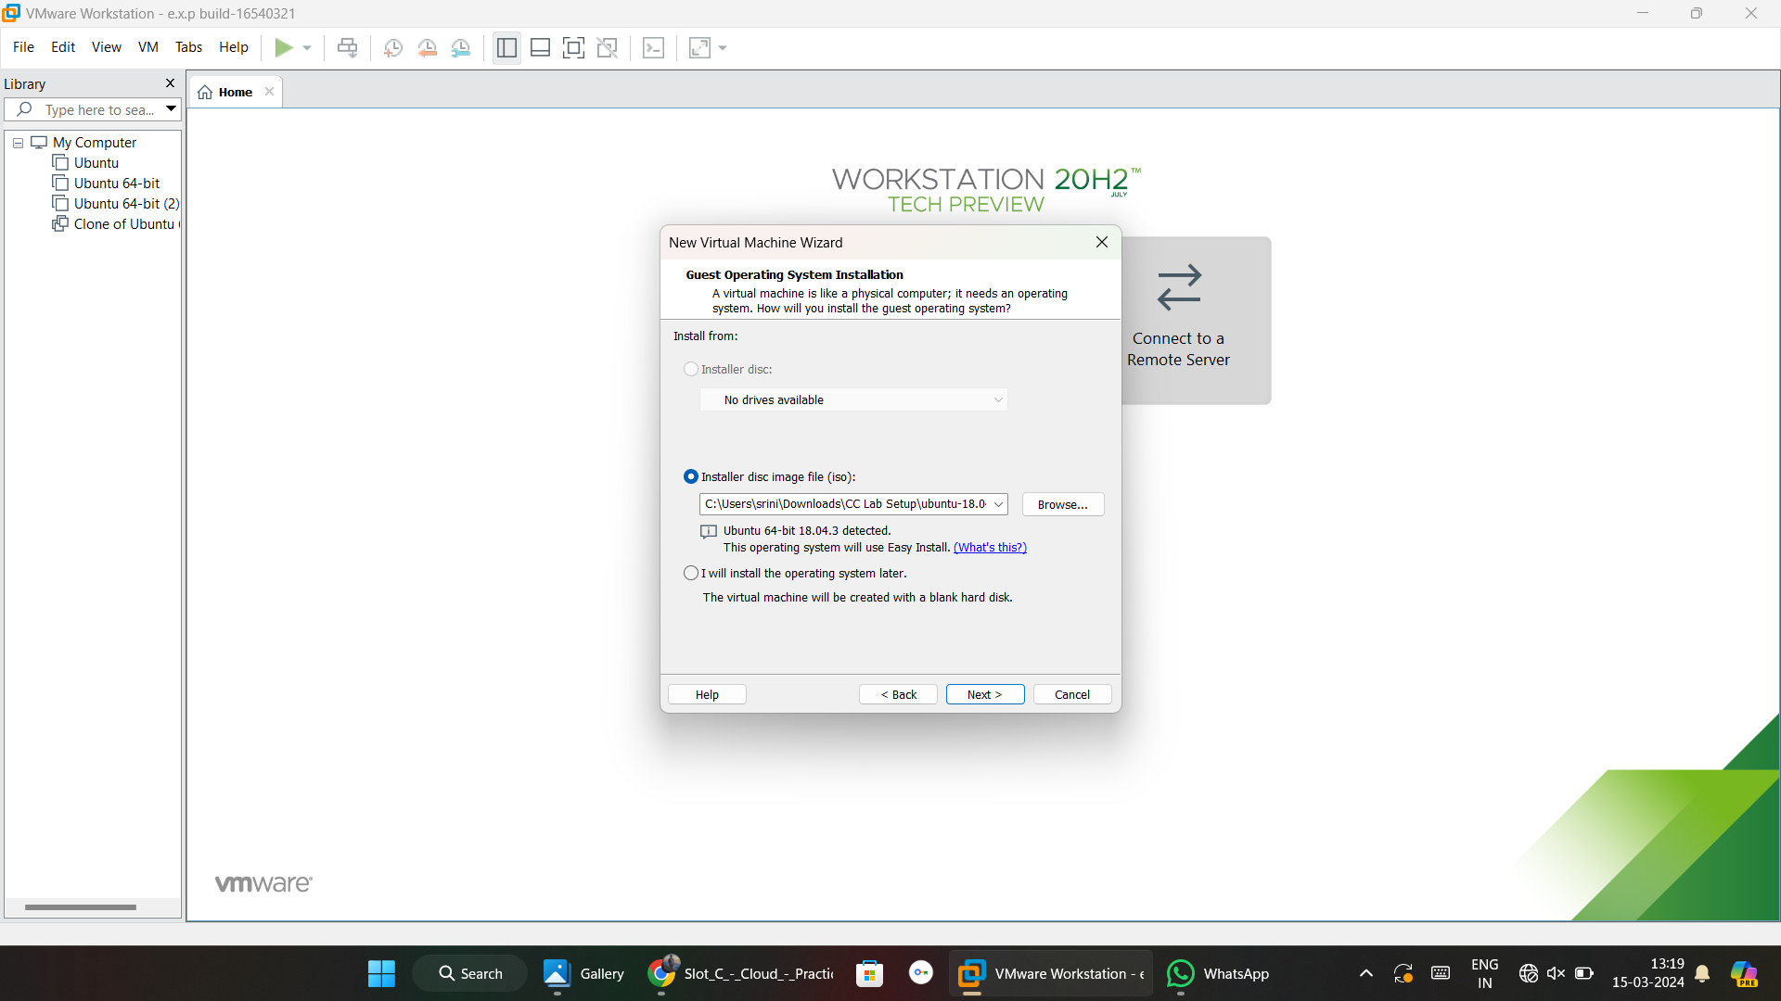Give login details for linux operating system.

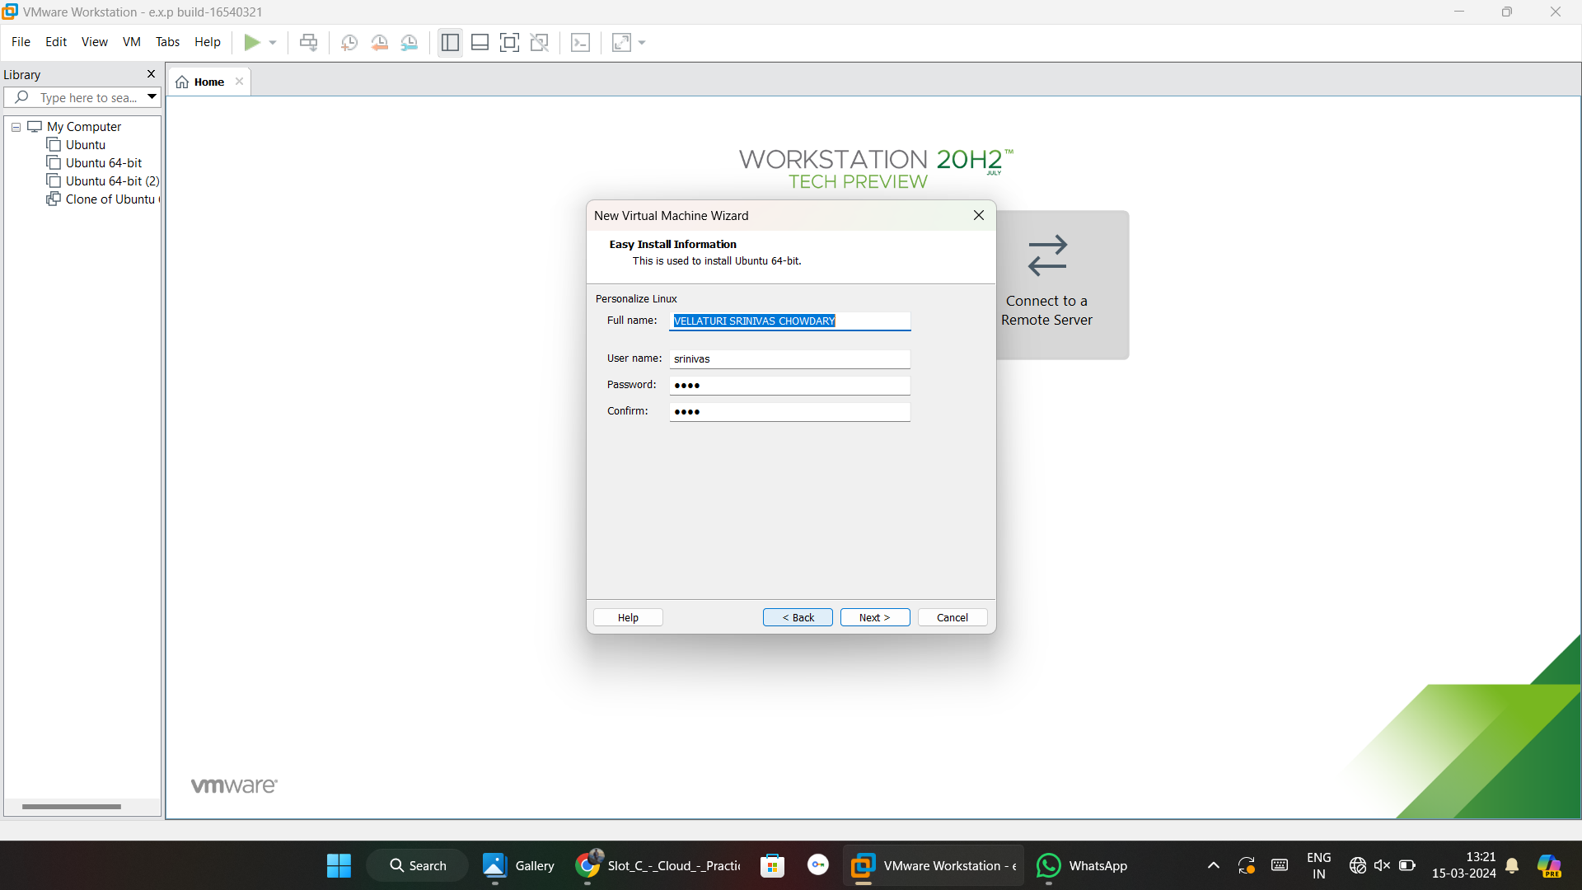

Give the disk size.

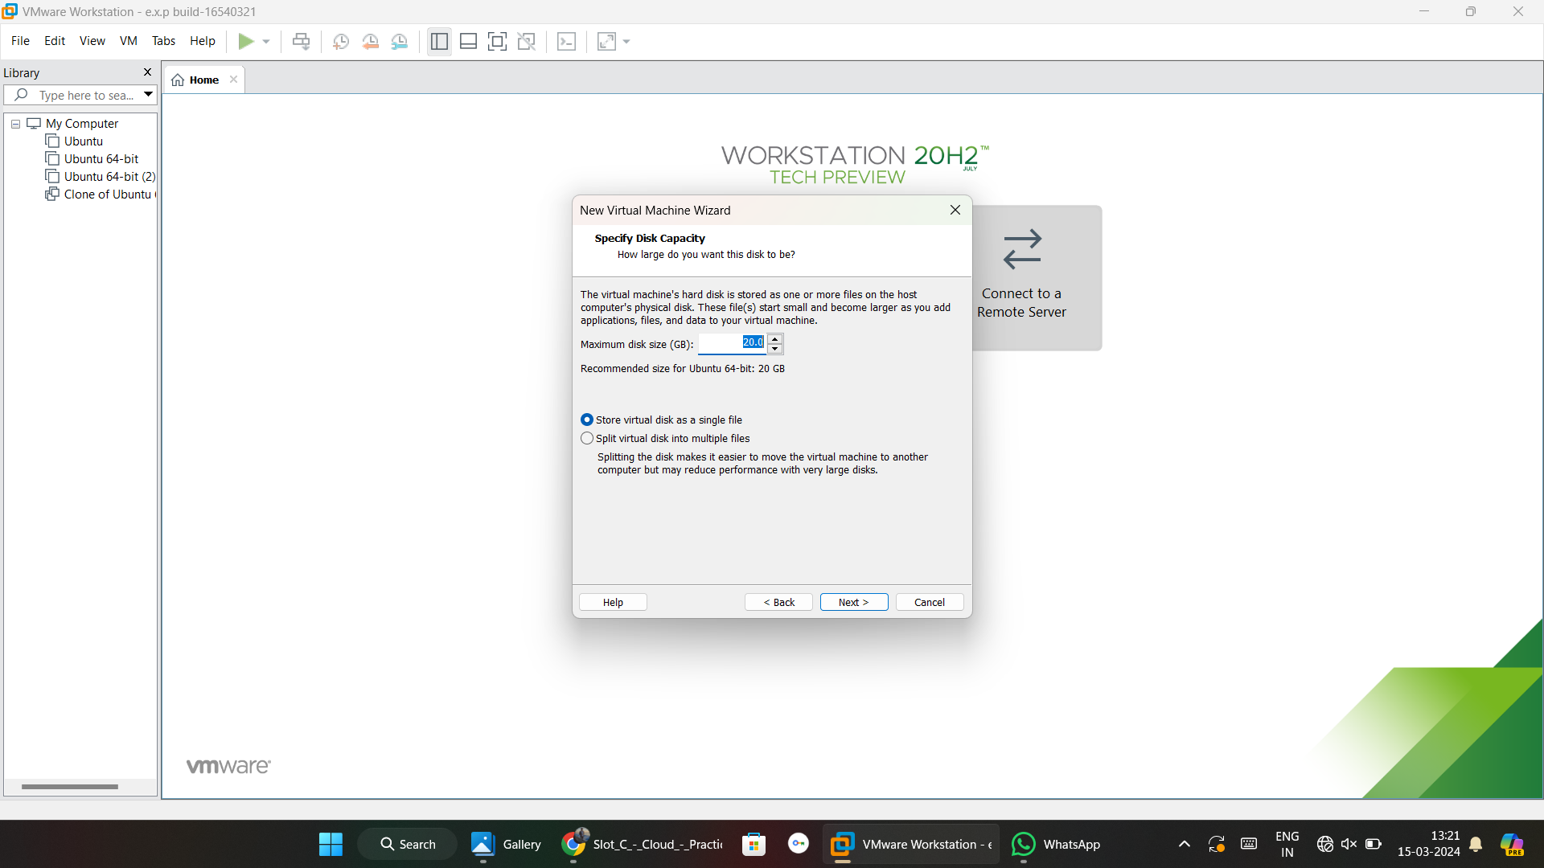

Here we can see virtual machine created details.

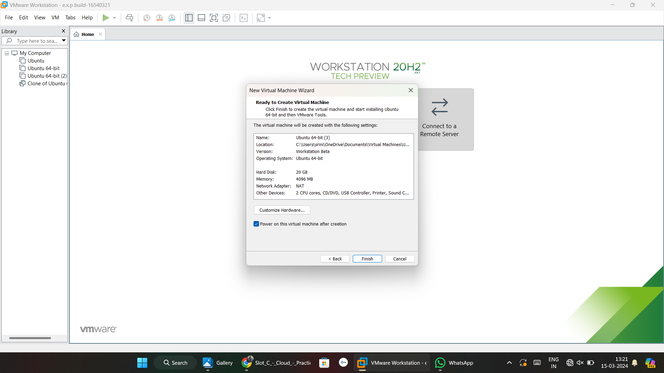

virtual machine created and now it was booting.

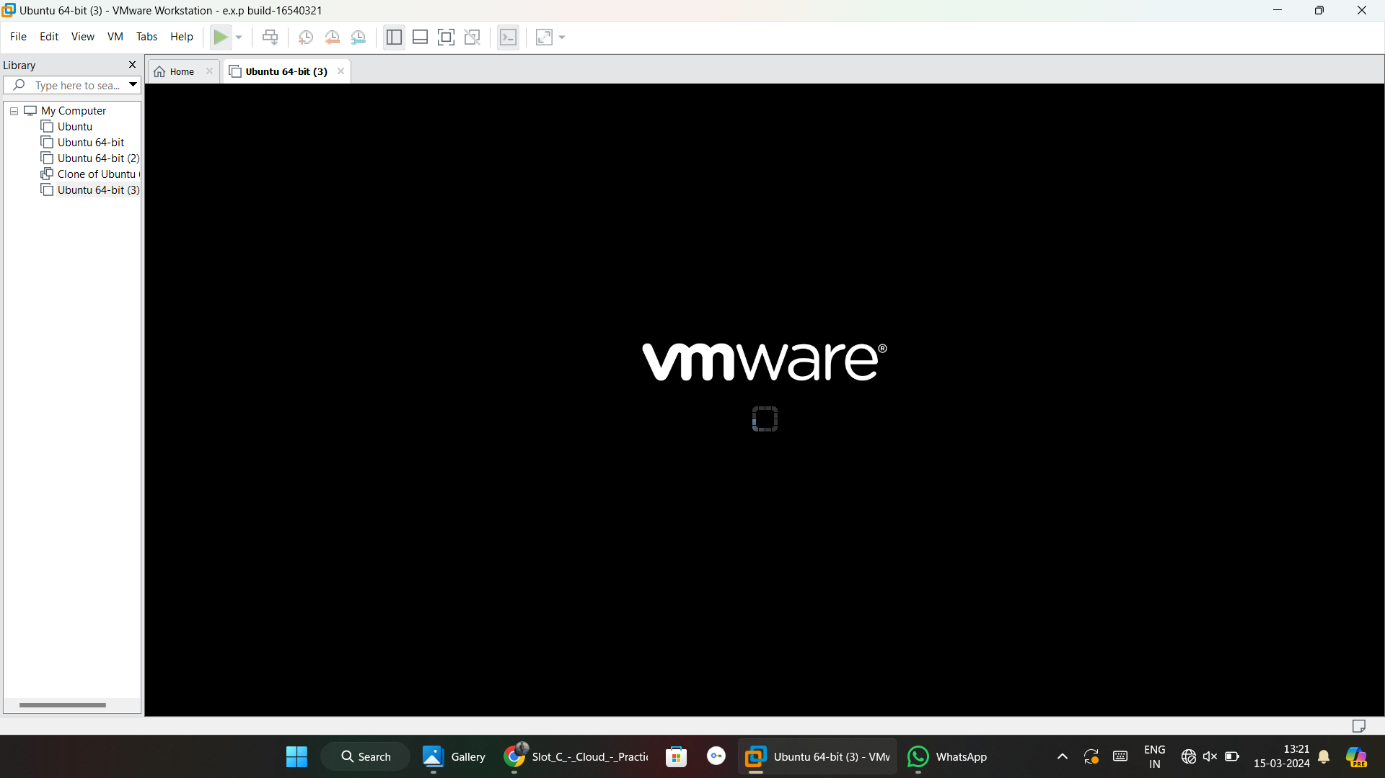

finally linux os is created.

